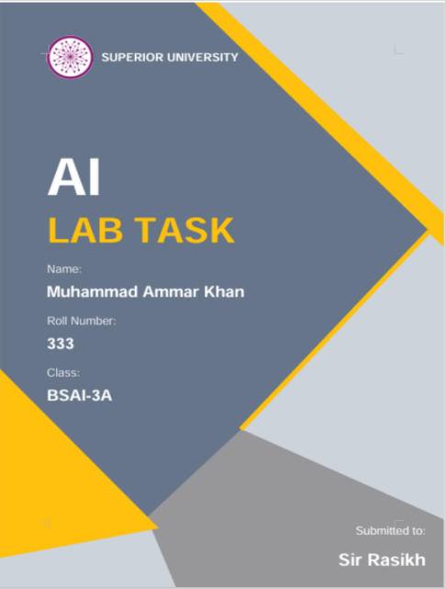

LAB 02 TASK REPORT

Assumptions I Made:
- Temperature is Celsius and occupied are True or False
- Modes are just label with no hardware
- An empty room are checked first
- Exactly 20 and 26 give IDLE as the code use only < and >

Problem Statement:
The problem is a smart classroom agent. It reads room temperature and check if anybody is sitting inside the room then it pick one mode from ECO, COOL, WARM or IDLE. The room should stay comfortable for whoever is inside & energy should not be wasted when the room is empty
In this lab I wrote the PEAS for two different systems & classified the environmant of each one. I also changed classroom agent soo it remembers last mode it used

Implementation Decisions:
The agent pick ECO, COOL, WARM or IDLE using temperature & whether room is occupied. An empty room is handled first by empty-room rule and at 20°C and 26°C the mode are IDLE in both case. The reflex agent look at the current percept only & the stateful agent sends a new command only when target mode changes. Both agent were testad with repeat percepts, boundary values mode transitions empty-room cases & changing temperature. Everything run on fix rules soo there is no learning no sensor-fault detection & no hysteresis

Task 1:
PEAS for the Delivery Robot

PEAS Part | Details
Performance | - Reach the drop point on time and safely  - Zero collisions  - Small battery usage
Environment | - Paths and corridors on campus  - Students, bikes and cars  - Weather and lighting
Actuators | - Steering and wheel motors  - Brake system  - Lights and horn
Sensors | - A camera  - An ultrasonic sensor  - GPS module  - Battery sensor and wheel encoders

Trade-off in Performance:
When fast delivery are the only thing reward the robot can end up driving two fast near people. That is why safety has to be part of performance measure for example a penalty for near misses & a speed limit in crowded place

Operating Assumptions:
- The robot only run on campus paths during daytime
- The app provides pickup point and drop point along with the receiver name.
- GPS work outdoors & the robot move at a walk speed
- The robot can stop immediately when a person get too close.
- If robot get stuck human operator ten take over

PEAS for the LLM-Based Student-Support Agent

PEAS Part | Details
Performance | - Student issues solved or passed to staff  - Fast replies  - Student data kept private
Environment | - Students in the chat  - FAQ and policy documents of the university  - Support staff and the student portal
Actuators | - Written reply  - Ticket creation  - Asking a follow-up question
Sensors | - Student message and chat history  - Document search  - Login details  - Status of the ticket

Performance Constraint:
If quick replies are rewardad the agent might answer without any proof. A good answer therefore need a source & if agent cannot find one it should say "I am not sure" and pass case to staff

Tools Available to the Agent:
- Look through the FAQ & policy document (read only)
- Create a support ticket that helps the student
- Pass case on to staff member
- Read student ID & the role of the logged in user

The agent cannot change grades fee or record and it cannot see other student data browse the internet or run code. I also assume the student is logged in and documents are mostly up to date & staff is available

Task 2: Type of Environment:

Which System | Type | Reason | Example Case
The delivery robot | Partially observable | The sensors cannot see everything | Hidden: the direction a person will walk next.
The delivery robot | Stochastic | The same action can give a different result | Uncertain: a wheel can slip on wet ground. Predictable: a brake command stops the motor.
The support agent | Partially observable | It only seas the messages and the documents it finds | Hidden: the real situation of the student or an outdated document.
The support agent | Stochastic | Search results and student replies can change | Uncertain: how the student will react. Predictable: a ticket gets created.

Simulator Versus Real Environment

1. The Delivery Robot
In the simulator: Using a grid map where every obstacle is known & every move work exactly as expect the simulator is fully observable & deterministic under these assumption
In the real world: The robot high miss some obstacle and wet ground or unexpected event can disturb its movement soo the real environment is partially observable and stochastic

2. The LLM-Based Student-Support Agent
In the simulator: The chatbot simulator work with a fix FAQ list that never change. It can be fully observable & deterministic if all the relevant information is available and every action gives fixed result
In the real world: A real university support system is different because the agent may not have all information about the student's situation. Questions & replies from students can also vary soo the real environment is partially observable and stochastic

3. The Classroom Script
In the simulator: For same input the classroom script always gives same output bcz it follows predefined rules soo it is deterministic
In the real world: In a real classroom there can be sensor faults and changing weather or other unexpected conditions. Because of these the real environment can become partially observable and stochastic

Task 3:
The reflex agent (lab2_percepts.py) only look at the current percept. The output was COOL, COOL, IDLE, IDLE, WARM & ECO & this matches the expect modes. COOL come twice bcz the agent has no memory of last mode
The stateful agent (lab2_model.py) store one extra value which are the previous mode. It give back target mode and flag that tall whether a command should be sent. A command goes out only when target differs from the previous mode while the thresholds & the empty-room rule stay same.

class StatefulClassroomAgent:
def __init__(self):
self.previous_mode = None # nothing sent yet
def decide(self, temp, occupied):
"""Same rules as the reflex agent."""
if not occupied:
return "ECO"
if temp > 26:
return "COOL"
if temp < 20:
return "WARM"
return "IDLE"
def act(self, temp, occupied):
"""Returns (target_mode, send_command)."""
target = self.decide(temp, occupied)
send = target != self.previous_mode
self.previous_mode = target
return target, send

Mode Change Trace:
The table below come from the actual output of lab2_model.py (see section 12).
Complete required sequence:

Step | Last mode | Input | Chosen mode | Result | Prev. mode
1 | None | (29, True) | COOL | SEND COMMAND | None
2 | COOL | (29, True) | COOL | No command | COOL
3 | COOL | (20, True) | IDLE | SEND COMMAND | COOL
4 | IDLE | (26, True) | IDLE | No command | IDLE
5 | IDLE | (19, True) | WARM | SEND COMMAND | IDLE
6 | WARM | (29, False) | ECO | SEND COMMAND | WARM

Empty Room Test:

No. | Last mode | Input | Chosen mode | Result
1 | None | (29, True) | COOL | SEND COMMAND
2 | COOL | (29, False) | ECO | SEND COMMAND
3 | ECO | (15, False) | ECO | No command
4 | ECO | (29, True) | COOL | SEND COMMAND

Out of the 6 step the stateful agent sent only 4 commands while the reflex agent would have sent all 6. At (29, False) the room is hot but mode is still ECO which show the empty-room rule work

Classical Agent Versus LLM Agent:
Every decision of the classroom agent can be traced bcz it uses fix rules & a small state. The support agent keep its state as text & decides with a learn model which make it more flexible but it can be wrong or answer differently each time soo it needs sources and handover to staff

Failure and Edge Case:
Remembering the previous mode stop repeated command but it does not solve usual problem of input staying close to limit. Take full room where background noise or small change in the sensor reading make measured temperature go like this: 26.1°C -> 25.9°C -> 26.1°C -> 25.9°C

• Observed behavior: The agent flip between COOL & IDLE at every temparature check and it send commands back & forth very quickly
• Likely cause: Remembering just last made stops the same command from being repeat but it give no buffer zone to block the quick changes
• Proposed improvement: Add a Schmitt-trigger or a buffer area where cooling start when the temperature goes above 26.5°C and stops when it fall below 25.5°C

Responsible Use:
- Safety has to be in performance measure and not only speed
- The support agent must not answer without proof soo it should show source or ask staff.
- Student data should stay private and the agent should use only tools it is allow
- No password or private data go to GitHub.
- Source: Lab 2 manual, (Mr. Rasikh Ali). The manual gave base classroom code & the stateful part is my own

Limitations of the Work:
- The agent only uses temperature and occupancy
- No handle of sensor faults or comfort
- The stateful agent does not learn
- PEAS only describe the task not the policy

My Reflection:
- What I got from this lab: how to write PEAS & that sensor actions and goal is different thing
- Where I will use this: I will write PEAS first for any AI system & add safety to performance measure
- What I did not expect: the noisy test near 26 as I thought remember the mode would stop flip but it did not
- What I will change next time: add hysteresis from start and test noisy input sooner

Reference List:
- Superior University Lahore. Lab 2: Intelligent Agents & PEAS Framework. Laboratory Manual.
- Python Software Foundation. Python 3 Documentation. https://docs.python.org/3/
Output of lab2_percepts.py:
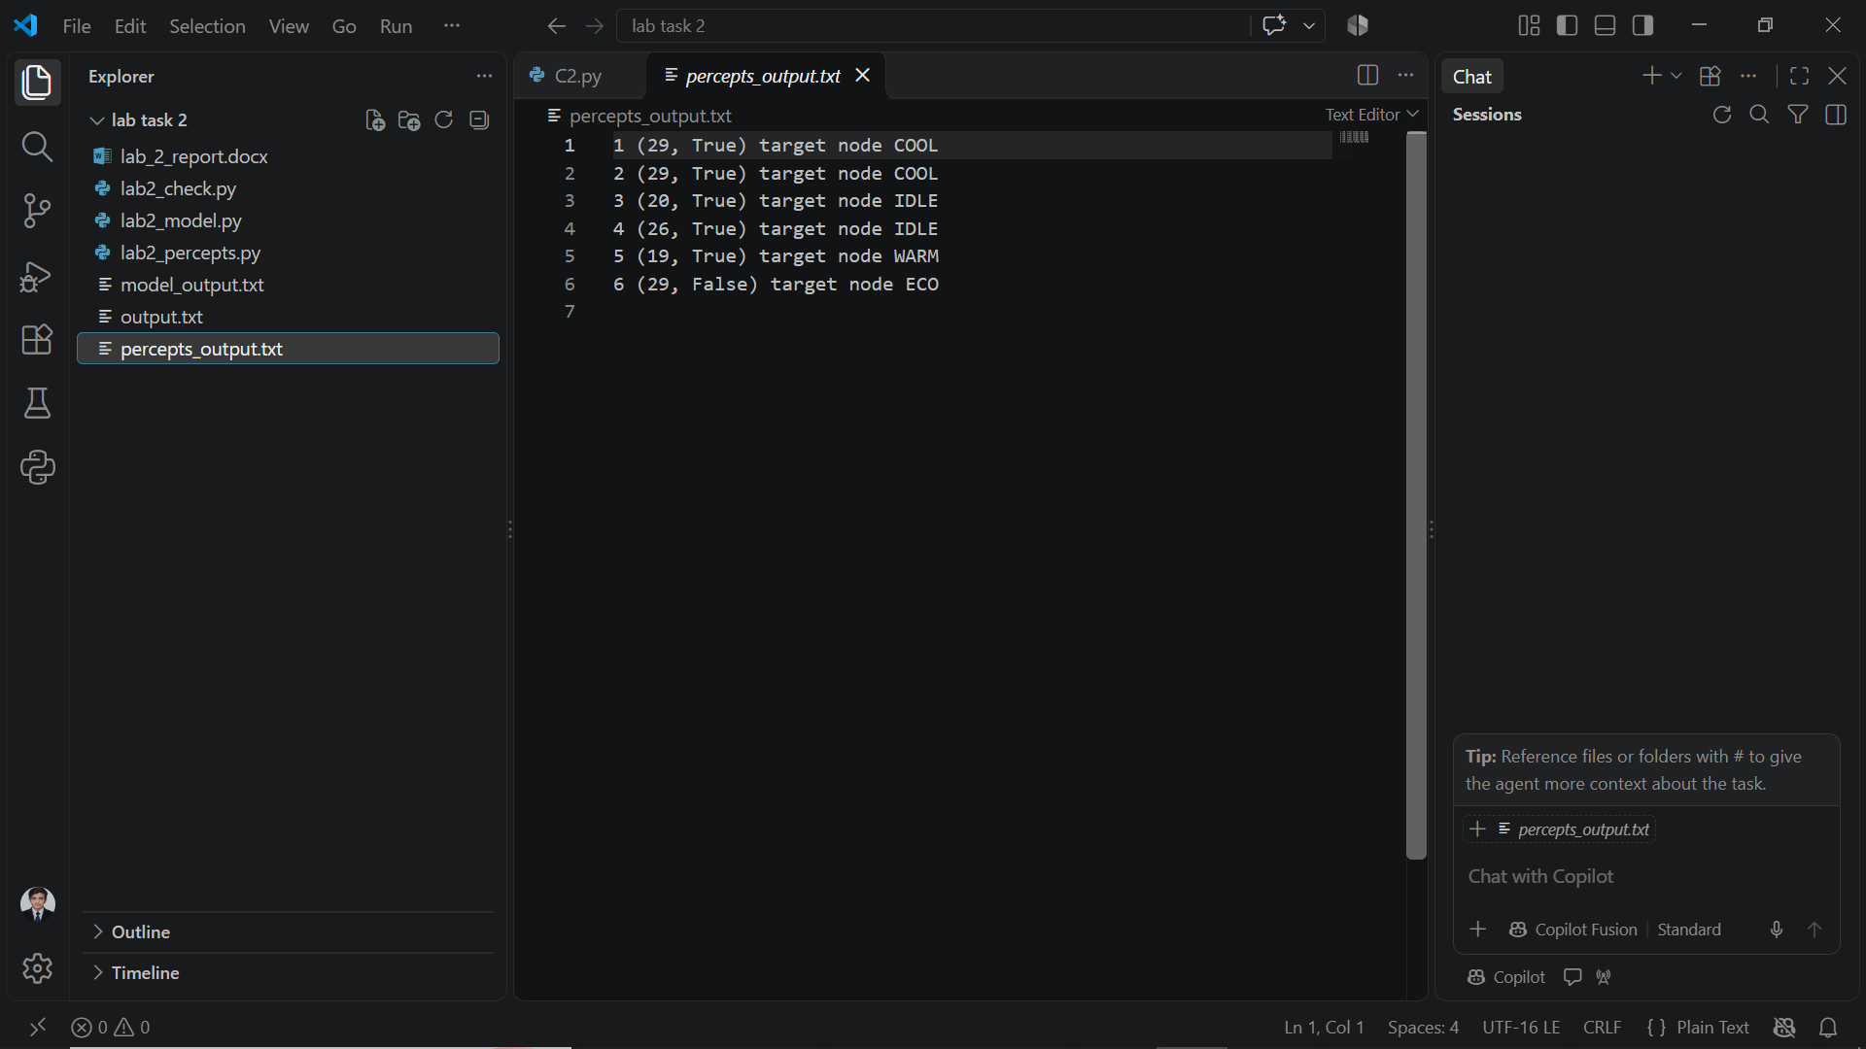

Output of lab2_model.py:
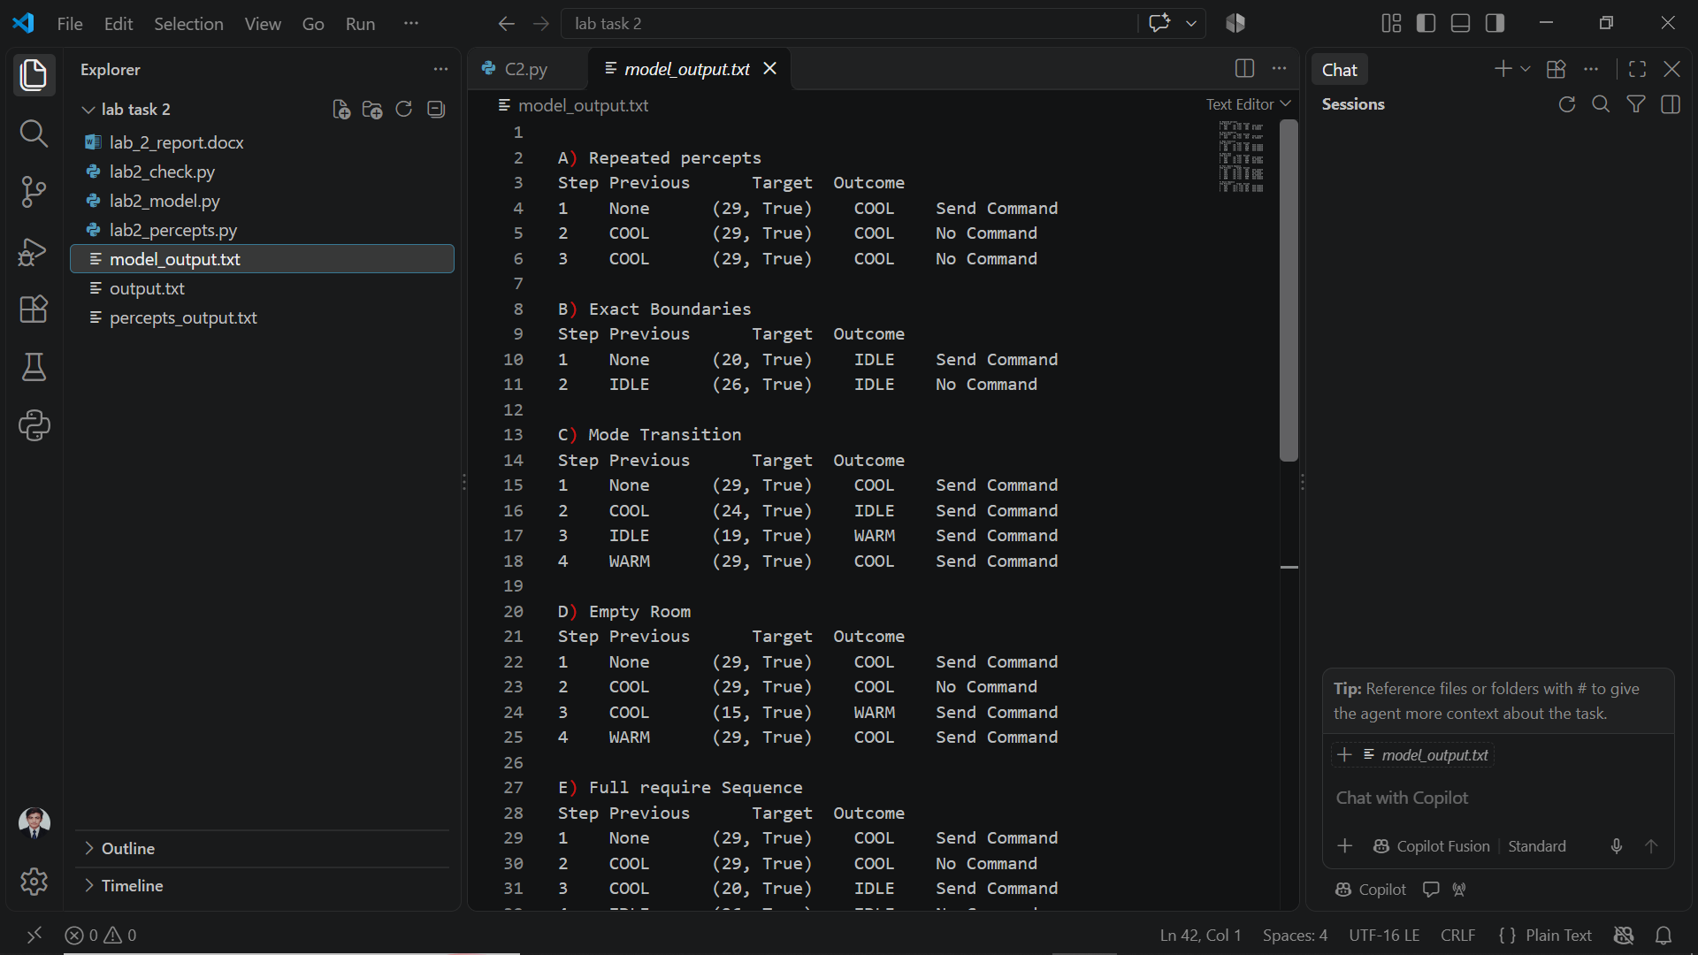
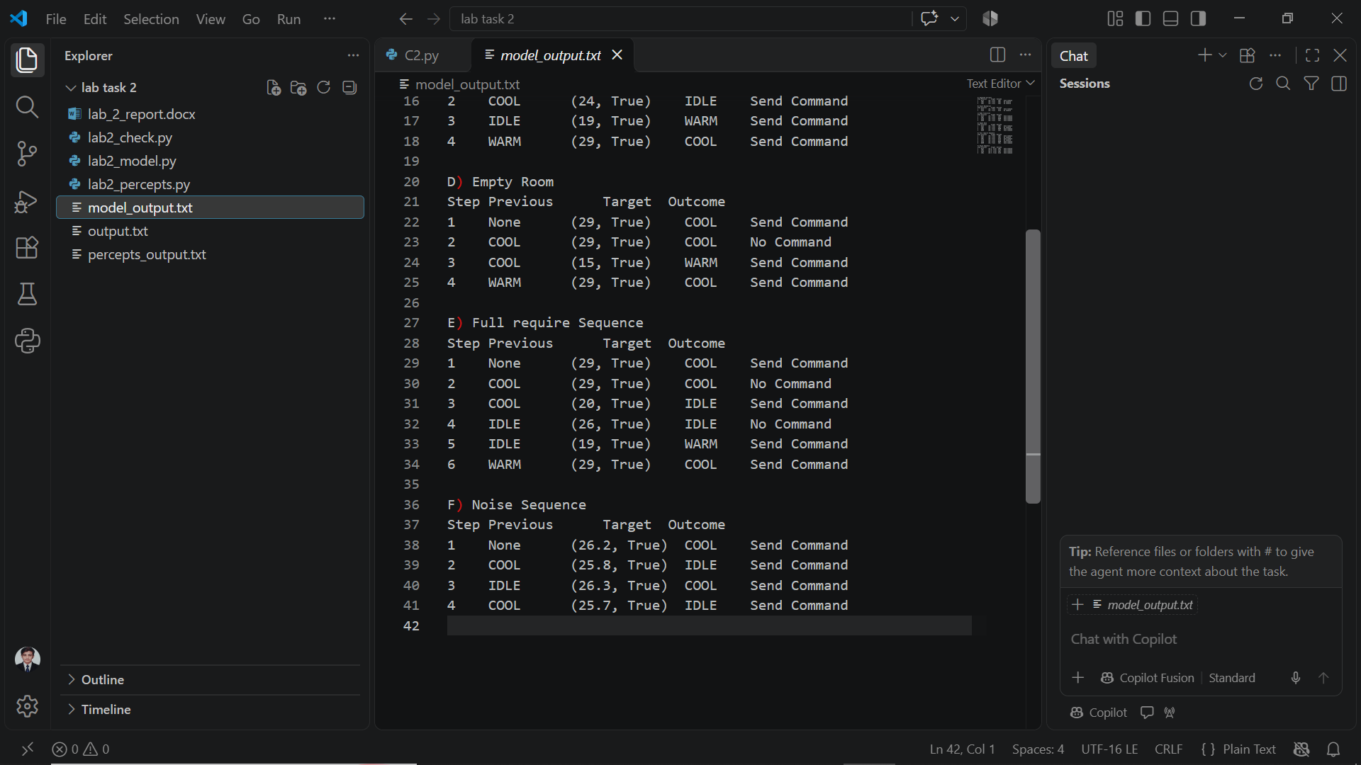

Output of lab2_check.py:


